**Course 12 Methods(Test 2 alternative) Year 12**

Student name: ________________ Teacher name: ________________

**Task type: Response**

**Time allowed for this task: ______45_____ mins**

**Number of questions: ______9_____**

**Materials required:** Calculator with CAS capability (to be provided by the student)

Standard items: Pens (blue/black preferred), pencils (including coloured), sharpener, correction fluid/tape, eraser, ruler, highlighters

Special items: Drawing instruments, templates, notes on one unfolded sheet of   
A4 paper, and up to three calculators approved for use in the WACE examinations

**Marks available: ___46___ marks**

**Task weighting: __10__%**

**Formula sheet provided: Yes**

**Note: All part questions worth more than 2 marks require working to obtain full marks.**

Q1 (3.2.1-3.2.3) (3 & 3 =6 marks)

Determine y in terms of x for the following.

1.  given that .

|  |
| --- |
| **Solution** |
|  |
| **Specific behaviours** |
| 🗸 ant differentiates correctly  🗸 uses a constant  🗸 solves for constant correctly |

1.  given that .

|  |
| --- |
| **Solution** |
|  |
| **Specific behaviours** |
| 🗸 ant differentiates correctly  🗸 solves for multiped constant correctly  🗸 solves for added constant correctly |

Q2 (3.2.21-3.2.22) (4 marks)

An object is moving in a straight line such that its velocity  as a function time, seconds, is given by where  is a constant. The acceleration at time  seconds is  and is initially at the origin. Determine the displacement when seconds.

|  |
| --- |
| **Solution** |
| x= 6 metres |
| **Specific behaviours** |
| 🗸 differentiates to determine acceleration  🗸 solves for p correctly  🗸 integrates to determine displacement **and states** a constant c  🗸 determines displacement |

Q3 (3.2.10-3.2.11) (3 & 4 = 7 marks)

Consider the function  which is graphed for . The arc has a radius of 2 units.

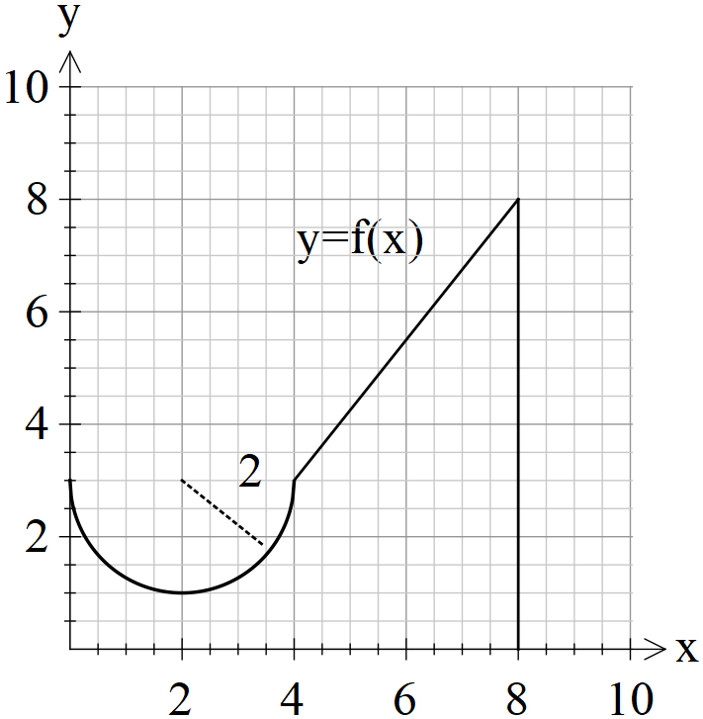

1. Determine the exact value of .

|  |
| --- |
| **Solution** |
|  |
| **Specific behaviours** |
| 🗸 determines area under arc  🗸 determines area of trapezium  🗸 express the exact value in terms of pi |

1. Determine to two decimal places such that 

|  |
| --- |
| **Solution** |
|  |
| **Specific behaviours** |
| 🗸 determines equation of line  🗸 determines an expression in terms of alpha for area between 4 and alpha  🗸 determines an equation for alpha  🗸 solves for alpha to two decimal places |

Q4 (3.2.18-3.2.17) (3 & 2 = 5 marks)

A water tank has a leak and the volume of water contained, ,cubic metres, can be described by the following differential equation at time,  minutes, . The tank is initially full but is emptied in 15 minutes.

1. Determine the initial volume of water in the tank to the nearest cubic metre..

|  |
| --- |
| **Solution** |
| Volume = 7 cubic metres |
| **Specific behaviours** |
| 🗸 integrates or writes an integral  🗸 uses domain of 0 to 15 mins  🗸 determines initial volume ( no need to round nor units) |

1. Determine the change in volume in the third minute.

|  |
| --- |
| **Solution** |
|  |
| **Specific behaviours** |
| 🗸 writes an integral  🗸 uses correct limits from 2 to 3 minutes |

Q5 (3.2.11-3.2.14) (2, 2 & 2 = 6 marks)

Consider a function  that is defined for  with the following conditions.



With  for  and  for .

.

1. Determine .

|  |
| --- |
| **Solution** |
|  |
| **Specific behaviours** |
| 🗸 uses fundamental theorem  🗸 determines integral |

1. Determine  given that .

|  |
| --- |
| 1. **Solution** |
|  |
| **Specific behaviours** |
| 🗸 uses additive property  🗸 determines integral |

(d) Determine  when .

|  |
| --- |
| 1. **Solution** |
|  |
| **Specific behaviours** |
| 🗸 uses fundamental theorem  🗸 determines value |

Q6 (3.2.20) (4 marks)

Determine to two decimal places the area between the curves  and .

(Hint- Sketch the curves first on your classpad)

|  |
| --- |
| **Solution** |
| Area equals 111.72 units |
| **Specific behaviours** |
| 🗸 determines both points of intersection  🗸 identifies which curve is on top or uses absolute value  🗸 writes an appropriate integral  🗸 determines area rounded to 2 dp |

Q7 (3.2.16) (1 & 3 = 4 marks)

Consider 

1. In terms of , express .

|  |
| --- |
| **Solution** |
|  |
| **Specific behaviours** |
| 🗸 determines expression |

1. If  and , determine  in terms of  only.

|  |
| --- |
| **Solution** |
|  |
| **Specific behaviours** |
| 🗸 determines f(x)  🗸 uses an integral with parameter t and rule f to define y  🗸 determines expression of y in terms of x only |

Q8 (3.1.4) (4 marks)

A radioactive substance ZZZ initially has a mass of 230 grams and decays according to  where  equals the mass at time  minutes and  is a constant. After 6 minutes the mass is 176 grams. Determine the time taken for half the mass to decay(half-life) and the value of  to three decimal places.

|  |
| --- |
| **Solution** |
|  |
| **Specific behaviours** |
| 🗸 uses an exponential model  🗸 solves for k  🗸 sets up an equation to solve for half life  🗸 solves for half life (no need to round nor units) |

Q9 (3.2.6) (2 & 4 =6 marks)

1. Determine .

|  |
| --- |
| **Solution** |
|  |
| **Specific behaviours** |
| 🗸 uses product rule  🗸 determines derivative |

1. Using your result from part (a) and **without using your classpad** determine .

|  |
| --- |
| **Solution** |
|  |
| **Specific behaviours** |
| 🗸 attempts to integrate both sides of result in a (lineraity)  🗸 uses fundamental theorem  🗸 integrates all terms correctly  🗸 determines required integral |

**Working out space**

**Working out space**